meeting Minutes
TDWG RASD Task group
Date: | 24 April 2026
Time: | 20:00 – 21:00 AEST
Chairperson | Cameron Slatyer

In attendance

John Wieczorek, Simon Sherrin, Tania Laity, Cam Slatyer, Debora Arlt, Alice Hughes, Will Morris.

Apologies

Andrew Rodrigues, Piers Higgs, Mieke Srong, Niels Raes

Introduction and Welcome
Cam did a Welcome to Country.

Cam presented a diagram which intends to illustrate the documentation required to submit the proposed RASD extension as a vocabulary enhancement to Darwin Core (based on John’s email of the 27 March 2026). The products which will need to be created include:
- Vocabulary enhancement element
- User feedback report element
- Metadata elements
- Schemas for Darwin Core and Darwin Core Data Package.

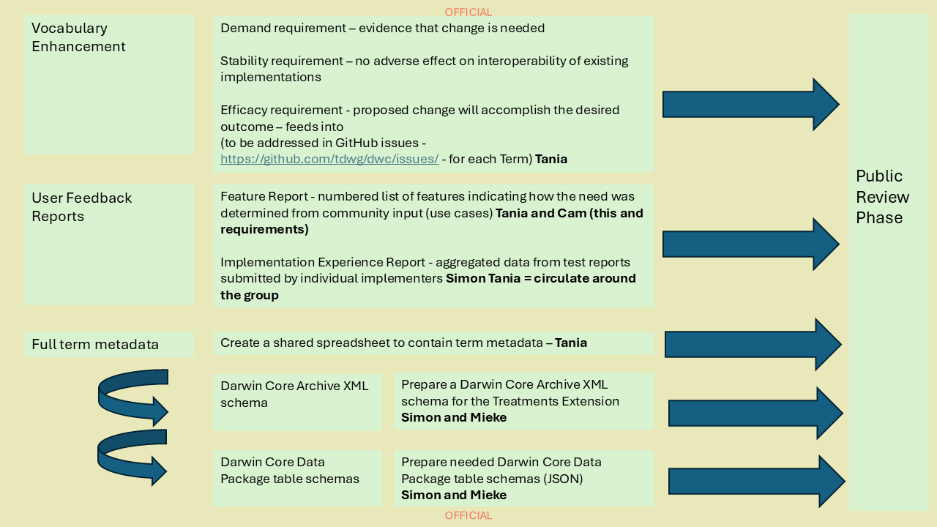

Next Steps
John clarified that the documents have to be submitted initially through the Darwin Core Maintenance Group. The Maintenance Group are also available to assist with refining the documentation.

The vocabulary enhancement element of the documentation requires all terms to be included in the DWC GitHub repository by using the New Term template. Each term will require the demand, stability and efficacy requirements to be addressed. Stability is referring to any impact on existing terms – so is not relevant to the RASD extension.

ACTION: Tania to create GitHub issues for all new terms

John clarified that the Feature and Implementation Experience Reports can be submitted as one document. Tania has started a draft but asked for clarification on what constitutes testing – do the use cases and amending the vocabularies to ensure that they fit constitute testing? Also does the dummy data in the draft schema that Simon presented at the January 2026 meeting constitute testing?. John confirmed that we would need to create a new table with real data in it for it to constitute testing.

ACTION: Simon and Tania to work on a more comprehensive mapping of real data to the draft schema tables for reasons and treatments and circulate to the wider group to test it.

Tania has made a start on the vocabulary csv file – based it on the Chronometric Age and Humboldt core ones – Mieke had already done a lot of work on this already which was a real help. Tania asked for clarification on how to reflect the hierarchical nature of the vocabulary in the csv – John and Will provided the example of the pathway terms - https://github.com/tdwg/rs.tdwg.org/blob/master/process/dwc-revisions/pw-2025-06-12/pathway_terms_2025-06-12.csv and provenance for the gitHub terms - Summary - Provenance · Issue #582 · tdwg/dwc
ACTION: Tania to update the csv file to include a skos_broader column to reflect the hierarchy of the vocabularies.

ACTION: Tania to circulate drafts of the Feature Report and Implementation Experience Report once drafted to the Task Group for review.

Simon mentioned that he and Mieke have done a fair bit of work already on the schemas but need to get them into the appropriate formats for submission. John confirmed that the Task Group has to decide if it wants the Darwin Core Maintenance Group to take over the role of schema management once the vocabulary enhancement has been ratified.

ACTION: Simon and Mieke to refine the Darwin Core (xml) and Darwing Core Data Package (json) Schemas

ACTION: Task Group members to advise if they have an aversion to the DWC Maintenance Group taking over the schema management once it has been ratified.

Cam clarified with John when the best time to create the full documentation on the vocabulary enhancement would need to be done. It was concluded that it might be best to start drafting it now so it’s easier to complete once the public review period has finished.

ACITON: Cam and Tania to start drafting this.

Next meeting

To be determined, however the annual TDWG Working Group Sessions for the Sensitive Species Task Group have been scheduled in time zones for eastern and western hemisphere in UTC+10 8:00 13 May and UTC+10 20:00 13 May.

Online working sessions aim to:

inform the wider biodiversity informatics community about the on-going work to develop and maintain standards;

review progress to date;

engage new contributors; and

set the agenda for work.
And we will be using this years sessions to give the broader community an update on where we are up to. Tania will include the calendar appointments in the minutes email. Members should not feel obliged to attend both meetings, but if you could make one, that would be excellent.

To register for one of these sessions go here – https://www.tdwg.org/community/working-sessions/2026/

If you are interested but can’t make it – all sessions will be recorded and posted to TDWG’s YouTube channel shortly afterwards.

